REPORT ON PROJECT PHASE 1

fingerprint based attendance system

submitted to savitribai phule pune university
for partial fulfilment
of the requirements for the deegree of

Bachelor of engineering
in
ELECTRONICS AND TELECOMMUNICATION

By
MR. NEHAL BANDAL
MR. SANKALP GUPTA
MR. HEMANT DUKRE

GUIDE
DR. Y. RAVINDER

Department Of
Electronics and TELECommunication ENGINEERING
PUNE INSTITUTE OF COMPUTER TECHNOLOGY
PUNE – 43

ACADEMIC YEAR: 2017 - 2018

Department of Electronics and Telecommunication Engineering
Pune Institute of Computer Technology, Pune – 43

CERTIFICATE

This is to certify that the Project Phase I Report entitled
“Fingerprint based Attendance System”
has been successfully completed by

Nihal Bandal (4507)
Sankalp Gupta (4520)
Hemant Dukre (4521)

towards the partial fulfillment of the degree of Bachelorof Engineering in Electronics and Telecommunication as awarded by the Savitribai Phule Pune University, at Pune Institute of Computer Technology during the academic year 2017-18.

Prof.Dr.Y.Ravinder Prof. Dr.Y.Ravinder
Project Guide HOD, E&TC Dept.

Department of Electronics and Telecommunication Engineering
Pune Institute of Computer Technology, Pune – 43

CERTIFICATE

This is to certify that the Project Phase I Report entitled
“Fingerprint based Attendance Sytem”
has been successfully completed by

MR. NEHAL BANDAL
MR. SANKALP GUPTA
MR. HEMANT DUKRE

towards the partial fulfillment of the degree of Bachelor of Engineering in Electronics and Telecommunication as awarded by the Savitribai Phule Pune University, at Pune Institute of Computer Technology during the academic year 2017-18.

Prof. Dr.Y.Ravinder Prof. Dr.Y.Ravinder
Project Guide HOED

ACKNOWLEDGEMENTS

The completion of phase-I of this project could not have been possible without the participation and assistance of so many people whose names may not all be enumerated. Their contributions are sincerely appreciated and gratefully acknowledged. However, the group would like to express their deep appreciation and indebtedness particularly to the following:

We express a deep sense of gratitude to Dr. Y.Ravinder (Project Guide)for their valuable guidance, keen interest, constructive criticism and encouragement at various stages in completion of this project.

Last but not least, we would like to express our gratitude to our friends and respondents for support and willingness to be there with us, to share their support, either morally, financially and physically, thank you.

Thanking You
MR. Nihal Bandal (4507)
MR. Sankalp Gupta (4520)
MR.Hemant Dukre (4521)

CONTENTS
 | Abstract |  | 5
 | List of Figures |  | 6
1 | Introduction |  | 7-11
 | 1.1 | Background | 7
 | 1.2 | Relevance | 8
 | 1.3 | Literature Survey | 8
 | 1.4 | Motivation | 8
 | 1.5 | Problem Definition | 9
 | 1.6 | Scopes And Objectives | 9
 | 1.7 | Technical Approach | 9
 | 1.8 | Organization of the Report | 10
2 | Attendance System |  | 11-15
 | 2.1 | Introduction | 11
 | 2.2 | Hardware - Software Level Design | 11
 | 2.3 | Attendance Management Approach | 12
 | 2.4 | On-Line Attendance Report Generation | 13
 | 2.5 | Network and Database Management | 13
 | 2.6 | Wireless network instead of LAN for portability | 13
3 | Progress of Project and Discussion |  | 18
4 | Conclusions |  | 19
 | 4.1 Outcomes of this Project |  | 19
5 | Future Plan |  | 21
6 | References |  | 22

ABSTRACT
Our project aims at designing a student attendance system which could executively manage attendance of students at institutes like PICT. Attendance is marked after student identification. For student identification, a fingerprint recognition based identification system is used. Fingerprints are considered to be the best and fastest method for biometric identification. They are secure to use, unique for every person and does not change in one's lifetime. Fingerprint recognition is a mature old to-day, but still identifying individual from a set of enrolled fingerprints is a time taking process. It was our responsibility to improve the fingerprint identification system for implementation on large databases e.g. of an institute or a country etc. In this project, many new algorithms have been used e.g. gender estimation, key based one to many matching, removing boundary minutiae. Using these new algorithms, we have developed an identification system which is faster in implementation than any other available today in the market. Although we are using this fingerprint identification system for student identification purpose in our project, the matching results are so good that it could perform very well on large databases like that of a country like India .

List of Figures

Figure 1.1: | Example of a ridge ending and a bifurcation
Figure 1.2: | Classroom Scenario
Figure 2.1: | Hardware present in classrooms
Figure 2.2: | Lan Network
Figure 2.3: | ER Diagram
Figure 2.4: | Level 0 DFD
Figure 2.5: | Level 1 DFD
Figure 2.6: | Level 2 DFD

CHAPTER 1

Introduction

Biometric Identification Systems are widely used for unique identification of humans mainly for verification and identification. Biometrics is used as a form of identity access management and access control. So use of biometrics in student attendance management system is a secure approach. There are many types of biometric systems like fingerprint recognition, face recognition, voice recognition, iris recognition, palm recognition etc. In this project, we used fingerprint recognition system.

1.1Background
Every organization whether it be an educational institution or business organization, it has to maintain a proper record of attendance of students or employees for effective functioning of organization. Designing a better attendance management system for students so that records be maintained with ease and accuracy was an important key behind motivating this project. This would improve accuracy of attendance records because it will remove all the hassles of roll calling and will save valuable time of the students as well as teachers.
Image processing and fingerprint recognition are very advanced today in terms of technology. It was our responsibility to improve fingerprint identification system. We decreased matching time by partitioning the database to one-tenth and improved matching using key based one to many matching

1.2 Relevance
Biometric Identification Systems are widely used for unique identification of humans mainly for verification and identification. Biometrics is used as a form of identity access management and access control. So use of biometrics in student attendance management system is a secure approach. There are many types of biometric systems like fingerprint recognition, face recognition, voice recognition, iris recognition, palm recognition etc. In this project, we used fingerprint recognition system.

1.3 Literature Survey
In biometrics, fingerprint is recognized as the most common modality among all biometric characteristics that have been studied so far [1], [2]. The advantages of the fingerprint could be attributed to several factors: 1) fingerprint pattern is stable and invariant which completely satisfies the requirement of uniqueness for being a biometric modality and 2) the use of fingerprint is also acceptable to people in comparison with other kinds of biometric modalities [3], [4], [2]. Therefore, besides the traditionally official applications, fingerprint also being adopted in civilian area since its study in modern biometrics had been proposed the 1960s [5], [6].
In this work fingerprint recognition has been performed by using Fast Fourier Transform and Gabor Filters [7]. It is used to enhance and reconstruct the information of the fingerprint image, as well as to extract two fundamental types of minutiae, ending points and bifurcations. Finally the extracted features are used to perform the fingerprint recognition.
A fingerprint, as a common sense, is composed of two kinds of lines namely fingerprint ridge and valley [6] which alternately run on the fingertip surface. The discontinuous flowing of ridge lines generate two types of minor features known as ridge ending and ridge bifurcation which are categorized as the minutiae points [8].

1.4 Motivation
Managing attendance records of students of an institute is a tedious task. It consumes time and paper both. To make all the attendance related work automatic and on-line, we have designed an attendance management system which could be implemented in PICT. It uses a fingerprint identification system developed in this project. This fingerprint identification system uses existing as well as new techniques in fingerprint recognition and matching. A new one to many matching algorithm for large databases has been introduced in this identification system.

1.5 Problem Definition
Designing a student attendance management system based on fingerprint recognition and faster one to many identifications that manages records for attendance in institutes like PICT.

1.6 Scope and Objectives
Manual attendance taking and report generation has its limitations. It is well enough for 30-60 students but when it comes to taking attendance of students large in number, it is difficult. For taking attendance for a lecture, a conference, etc. roll calling and manual attendance system is a failure. Time waste over responses of students, waste of paper etc. are the disadvantages of manual attendance system. Moreover, the attendance report is also not generated on time. Attendance report which is circulated over PICT webmail is two months old. To overcome these non-optimal situations, it is necessary that we should use an automatic on-line attendance management sys-tem. So we present an implementable attendance management framework. Student attendance system framework is divided into three parts : Hardware/Software Design, Attendance Management Approach and On-line Report Generation. Each of these is explained below.

1.7 Technical Approach
This part explains how students and teachers will use this attendance management system. Following points will make sure that attendance is marked correctly, without any problem:
(1)All the hardware will be inside classroom. So outside interference will be absent.

(2) To remove unauthorized access and unwanted attempt to corrupt the hardware by students, all the hardware except
fingerprint scanner could be put inside a small cabin. As an alternate solution, we can install CCTV cameras to prevent unprivileged activities.

(3) When teacher enters the classroom, the attendance marking will start. Computer software will start the process after inputting fingerprint of teacher. It will send the Subject ID, and Current Semester using the ID of the teacher or could be set manually on the software. If teacher doesn't enter classroom, attendance marking will not start.

(4) After some time, say 20 minutes of this process, no attendance will be given because of late entrance. This time period can be increased or decreased as per requirements.

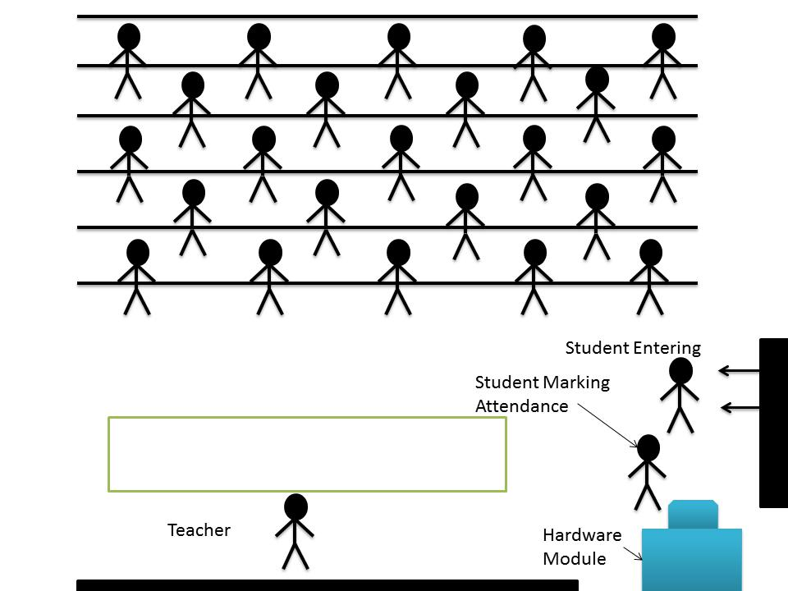

Figure 1.2: Classroom Scenari

1.8 Organization of Report
- Chapter 1 consists of brief introduction of the project and brief details of different aspects of project such as Problem definition, technical details, Literature survey etc.
- Chapter 2 consist of detailed explanation about project. This chapter explains the idea of project in detail and also discusses stuff related to it. It explains the structure of current attendance system. Also this explains the details about Remote attending system and compatibility of both systems. This chapter explains security features related to the project and database required for the project and their management.
- Chapter 3 shows the current progress of the project and work done so far in the project.
- Chapter 4 concludes this project report.
- Chapter 5 tells the future scope of the project.
- Chapter 6 contains the references for the project.

CHAPTER 2

Fingerprint Based System

An identification system is one which helps in identifying an individual among many people when detailed information is not available. It may involve matching available features of candidate like fingerprints with those already enrolled in database.

2.1 Introduction
Every organization whether it be an educational institution or business organization, it has to maintain a proper record of attendance of students or employees for effective functioning of organization. Designing a better attendance management system for students so that records be maintained with ease and accuracy was an important key behind motivating this project. This would improve accuracy of attendance records because it will remove all the hassles of roll calling and will save valuable time of the students as well as teachers.
Image processing and fingerprint recognition are very advanced today in terms of technology. It was our responsibility to improve fingerprint identification system. We decreased matching time by partitioning the database to one-tenth and improved matching using key based one to many matching

2.2 Hardware - Software Level Design

Required hardware used should be easy to maintain, implement and easily available.

Proposed hardware consists following parts:

(1)Fingerprint Scanner,

(2)Computer

(3)LAN connection

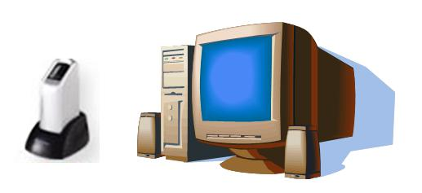
Fingerprint scanner will be used to input fingerprint of teachers/students into the computer software. PC will be displaying rolls of those whose attendance is marked. Computer Software will be interfacing fingerprint scanner and PC and will be connected to the network. It will input fingerprint, will process it and extract features for matching. After matching, it will update database attendance records of the students.

Figure 2.1: Hardware present in classrooms

2.3 Attendance Management Approach

This part explains how students and teachers will use this attendance management system. Following points will make sure that attendance is marked correctly, without any problem:

(1)All the hardware will be inside classroom. So outside interference will be absent.

(2)To remove unauthorized access and unwanted attempt to corrupt the hardware by students, all the hardware except fingerprint scanner could be put inside a small
cabin. As an alternate solution, we can install CCTV cameras to prevent unprivileged activities.

(3)When teacher enters the classroom, the attendance marking will start. Computer software will start the process after inputting fingerprint of teacher. It will send the Subject ID, and Current Semester using the ID of the teacher or could be set
manually on the software. If teacher doesn't enter classroom, attendance marking will not start.

(4)After some time, say 20 minutes of this process, no attendance will be given because of late entrance. This time period can be increased or decreased as per requirement

2.4 On-Line Attendance Report Generation

Database for attendance would be a table having following fields as a combination for primary field: (1)Day,(2)Roll,(3)Subject and following non-primary fields: (1)Attendance,(2)Semester. Using this table, all the attendance can be managed for a student.
which will access this table for showing attendance of students. The SQL queries will be used for report generation. Following query will give total numbers of classes held in subject CS423:

SELECT COUNT(DISTINCT Day) FROM Attendance Table WHERE SUB-JECT = CS423 AND Attendance = 1

For attendance of roll 107CS016, against this subject, following query will be used: SELECT COUNT(Day) FROM Attendance Table WHERE Roll = 107CS016 AND SUBJECT = CS423 AND Attendance = 1

2.5 Network and Database Management

This attendance system will be spread over a wide network from classrooms via intranet to internet. Network diagram is shown in g. 2.3. Using this network,
attendance reports will be made available over internet and e-mail. A monthly report will be sent to each student via email and website will show the updated attendance. Entity relationship diagram for database of students and attendance records is shown in g. 2.4. In ER diagram, primary fields are Roll, Date, SubjectID and TeacherID. Four tables are Student, Attendance, Subject and Teacher. Using this database, attendance could easily be maintained for students. Data ow is shown in data ow diagrams (DFD) shown in figures 2.5, 2.6 and 2.7.

2.6 Wireless network instead of LAN for portability

We are using LAN for communication among servers and hardware in the classrooms. We can instead use wireless LAN with portable devices. Portable device will have an embedded fingerprint scanner, wireless connection, a microprocessor loaded with a software, memory and a display terminal, see figure 2.2. Size of device could be small like a mobile phone depending upon how well the device is manufactured.

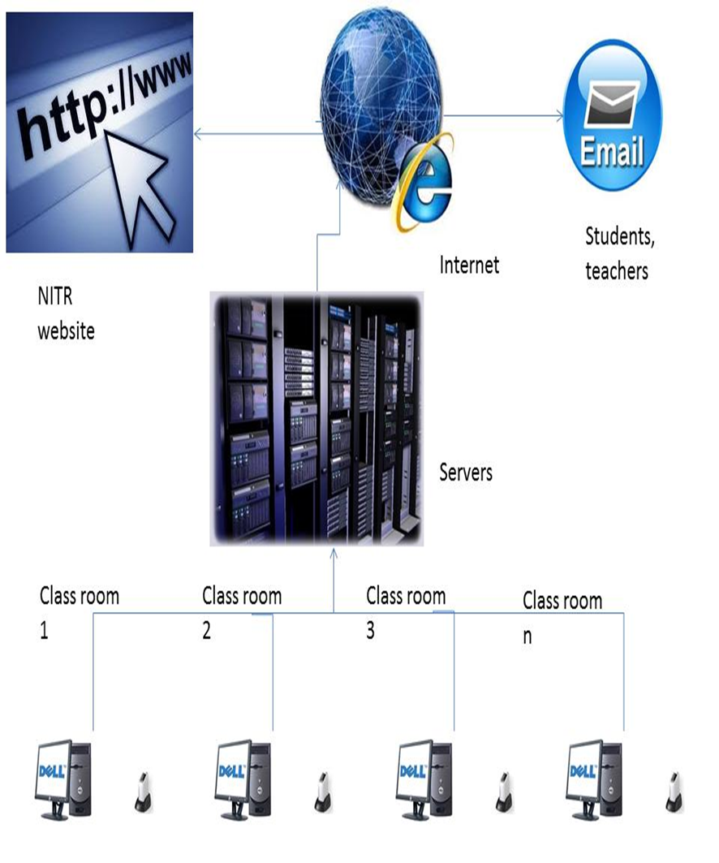

Figure 2.2: Lan Network

Figure 2.3: ER Diagram

Figure 2.4: Level 0 DFD

Figure 2.5: Level 1 DFD

Figure 2.6: Level 2 DFD

CHAPTER 3

Progress of Project and Discussion

Overview of the project is taken and some parts mentioned above are completed. Advantages and disadvantages of the project are discussed and problems faced while taking the overview are solved through the discussion with Project guide.
Initial installation of Raspbian OS on Raspberry Pi-3 and communicating and executing basic commands on Raspberry pi-3 using laptop is done. Also MySQL Queries for database implementation are studies. HTML for Web Development is also studied. Most important part of our database implementation i.e. ER Diagram is implemented. This ER-Diagram show the different relationship between different entities.
Installation of Apache server and PHP is successfully done in the Ubuntu environment. This server will be used in the server site to make communication between database and the webpage.

CHAPTER 4

Conclusions

This project mainly comprised of development of attendance management system and
fingerprint identification system. Attendance management is very helpful in saving
valuable time of students and teachers, paper and generating report at required time.
This project presented a framework using which attendance management can be made
automated and on-line. A general implementable approach to attendance management
was proposed using LAN.
Fingerprint Identification System used for student identification is faster in implementation than any other fingerprint identification systems. For fingerprint recognition, prevalent enhancement techniques like Gabor Filters[, minutiae extraction
using Crossing Number concept followed by spurious and boundary minutiae removal,
fingerprint classification, reference point detection, etc. are employed. Also, various new concepts are invented in this fingerprint identification system like gender
estimation and key based one to many matching. Fingerprint classification and gender estimation are employed to partition the database in order to reduce search space.

4.1 Outcomes of this Project

- A Scientific approach was developed during project work.
- We learn about DBMS and have successfully installed XAMPP application on the PC.
- Most important database management language i.e. MySQL is studied and small database of different entities is implemented in MySQL.
- We have learn about web development and HTML to create the webpages. Also, installing of apache server is studied and implemented successfully.
- Base of the project is completed and idea about remaining part is cleared.
- An applicable attendance management system was designed for educational organizations. Ideas were presented for making whole system online using portable device.
- Skills and self-confidence in coding and working with softwares like Xampp Application were developed.

CHAPTER 5

Future Plan

- Regarding our fingerprint identification system we are planning introduce more indexing techniques like ridge density tolerance etc. for making the search faster.
- Also the key used will be more efficient when complex key will be used. We are trying to reduce matching error rate.
- We have thought of using wireless LAN. The problem of using wireless LAN is that wireless devices are costly and hard to implement.
- As an alternate, we may use mobile website where the attendance will be updated.
- Fingerprint identification system will be improved further using more indexing techniques like ridge density tolerance etc.

CHAPTER 6

References

[1] A. F. Abate, M. Nappi, D. Riccio, and G. Sabatino, “2d and 3d face recognition: A survey,” vol. 28, no. 14. Elsevier, 2007, pp. 1885–1906.
[2] D. Maltoni, D. Maio, A. K. Jain, and S. Prabhakar, Handbook of fingerprint recognition. springer, 2009.
[3] N. K. Ratha, K. Karu, S. Chen, and A. K. Jain, “A real-time matching system for large fingerprint databases,” vol. 18, no. 8. IEEE, 1996, pp. 799–813.
[4] A. K. Jain, A. Ross, and S. Prabhakar, “An introduction to biometric recognition,” Circuits and Systems for Video Technology, IEEE Transactions on, vol. 14, no. 1, pp. 4–20, 2004.
[5] J. Wegstein, A semi-automated single fingerprint identification system. US Department of Commerce, N
[6] A. Jain, L. Hong, and S. Pankanti, “Biometric identification,” vol. 43, no. 2. ACM, 2000, pp. 90–98.
[7] Gualberto Aguilar, Gabriel Sanchez, “Fingerprint Recognition” IEEE, 2007
[8] N. K. Ratha, S. Chen, and A. K. Jain, “Adaptive flow orientation-based feature extraction in fingerprint images,” vol. 28, no. 11. Elsevier, 1995, pp. 1657–1672.

